MACH4METAL

metalworking machinery
Transito 21,
6909 DA BABBERICH
Netherlands
Tel. +31 (0)316 – 247123
Fax. +31 (0)316 - 247956
info@mach4metal.com
www.mach4metal.com

Bank No : 66.52.13.883
IBAN : NL33 INGB 0665 2138 83
BIC : INGBNL2A

MIG CASTOLIN Welding machine
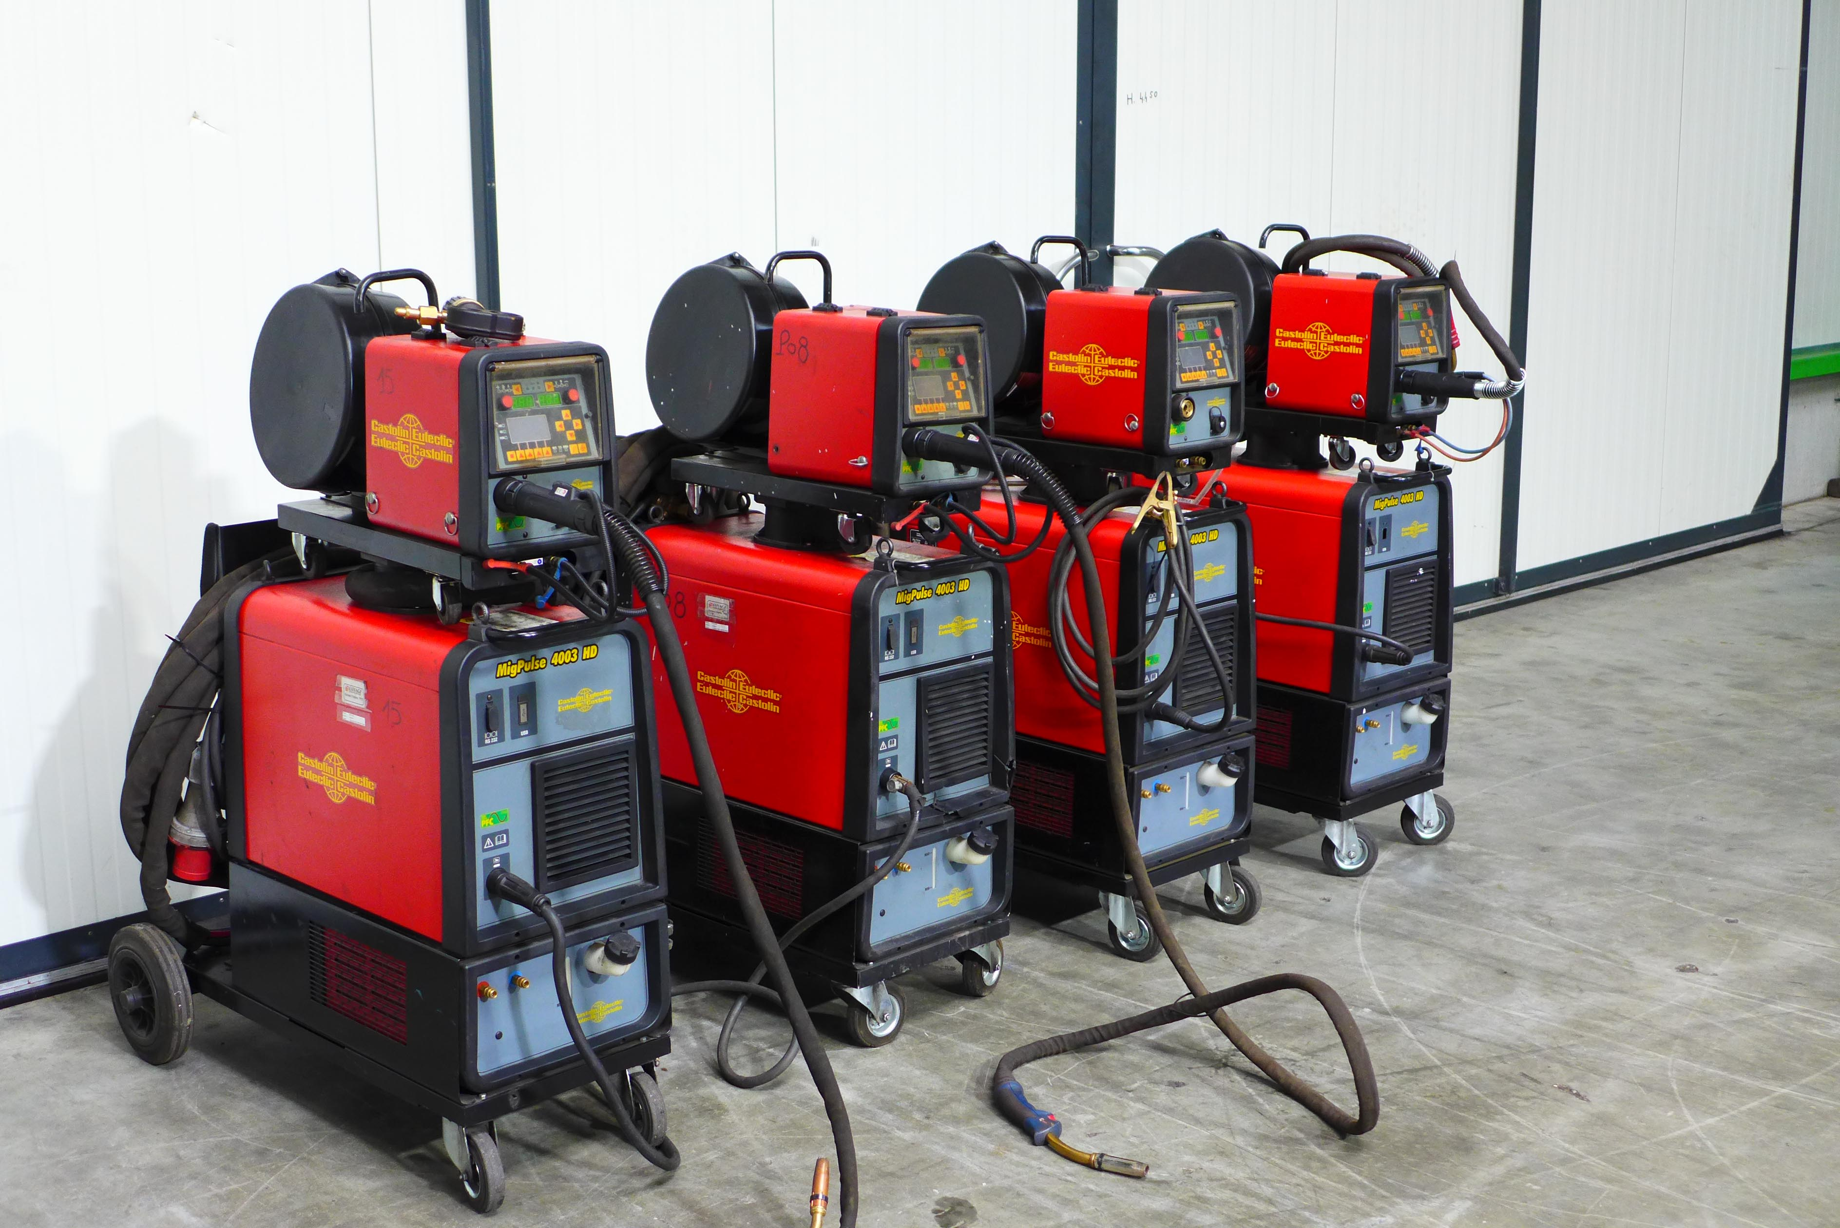
- Make : CASTOLIN
- Typ : MIG Pulse 4003 HD
- Mach. No :
- Age : 2010

- Output range
- Rated power 40 % : 380 A
- Rated power 60 % : 240 A
- Rated power 100 % : 310 A
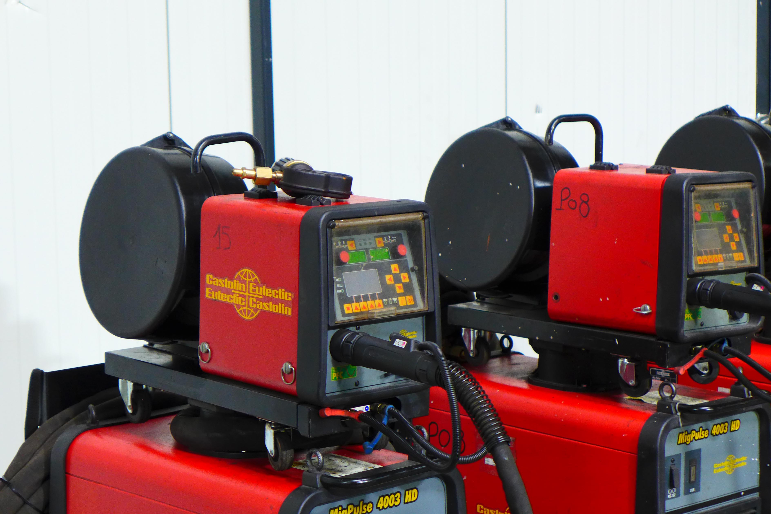
- Imput 10 – 380 A
- Tension 70 V

- Number off programs : 99
- Wire Ø : 0,8 – 1,6 mm
- Incl. separate feeder box

- Dimensions
- Length : 588
- Width : 1.087
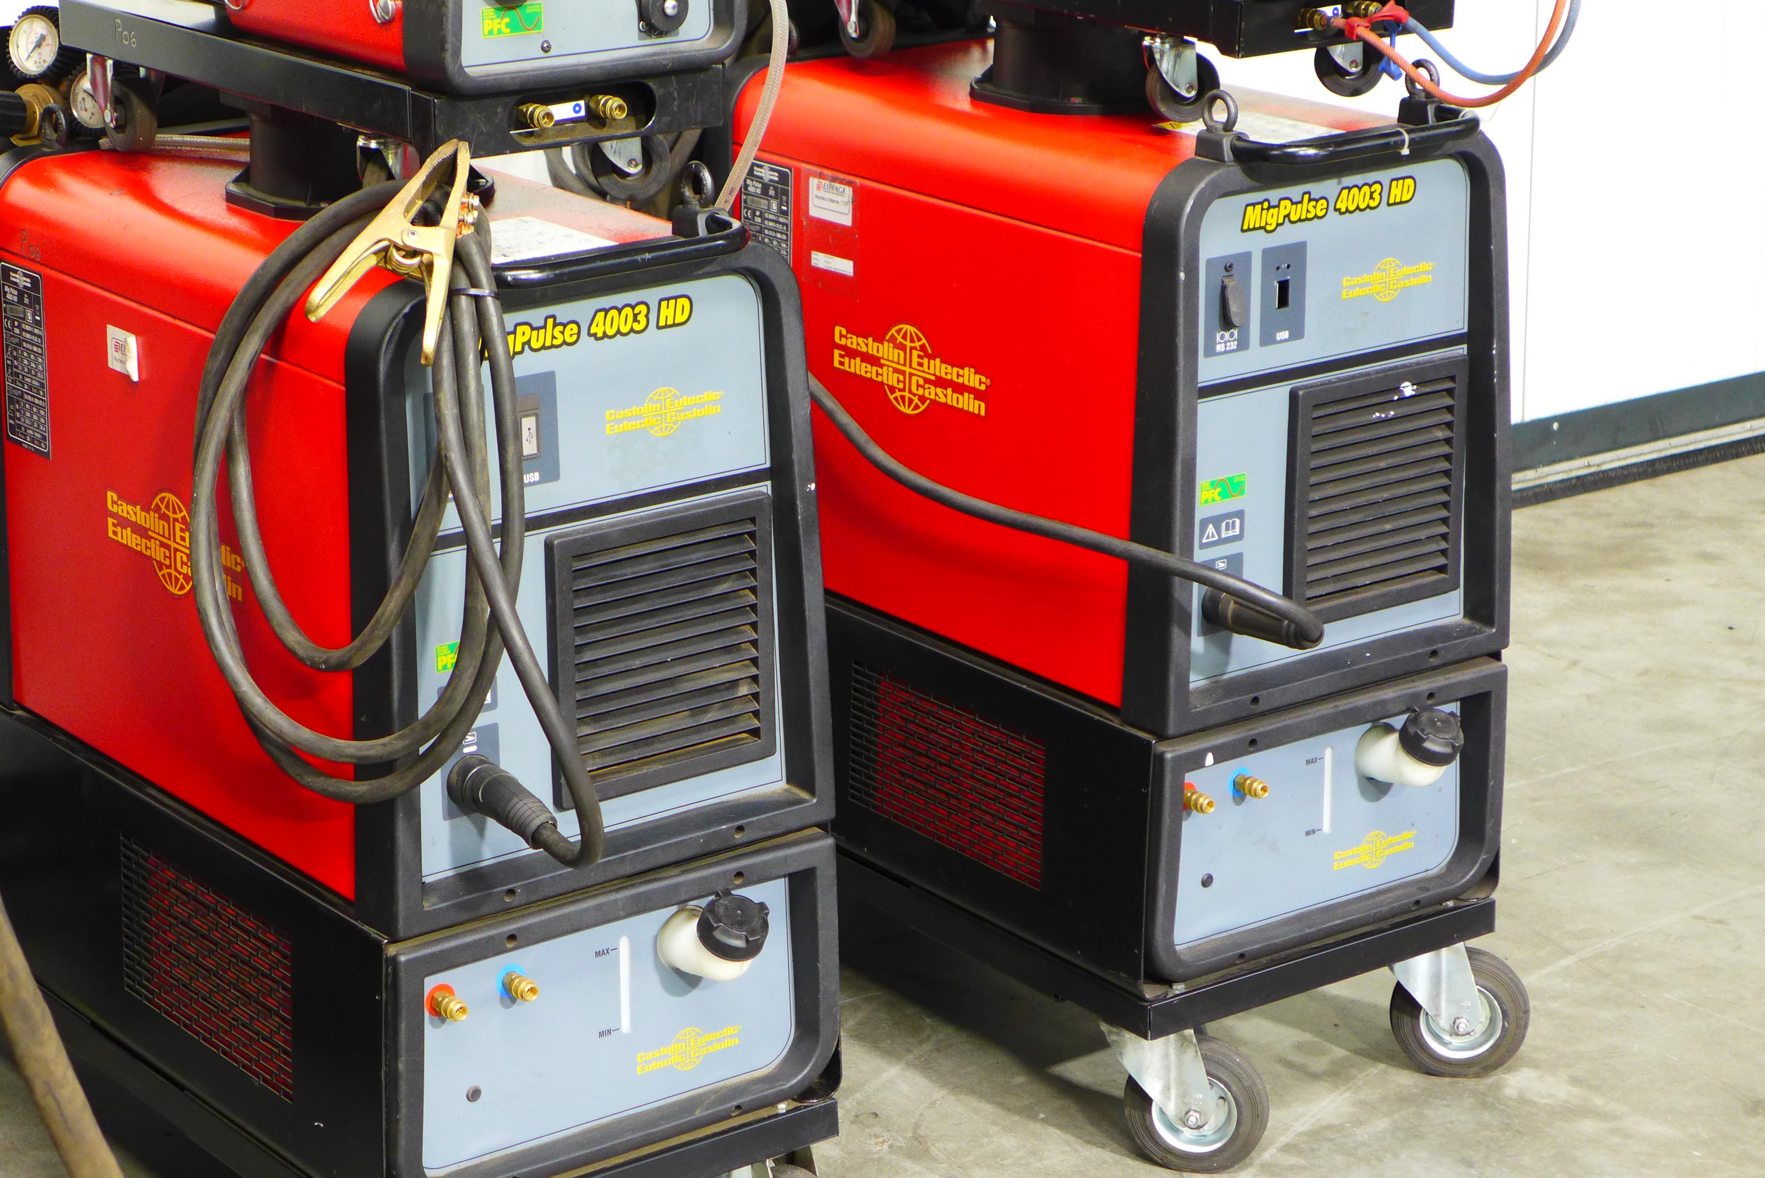
- Height : 1.396
- Weight : 122 Kg

- New EUR 6500

- 8 same pieces in stock

Please Note: The above information has been obtained to the best of our ability and belief from, and from the manufacturers where possible. It is given in good faith, but its accuracy can not be guaranteed. Accordingly, it will not form a representation or constitute contractual terms. We advise you to check any vital details!

